
1507 Laporte Ave., Fort Collins, CO 80521 | 970.988.4290 | ben@hibeams.com

Stage Plot 2010

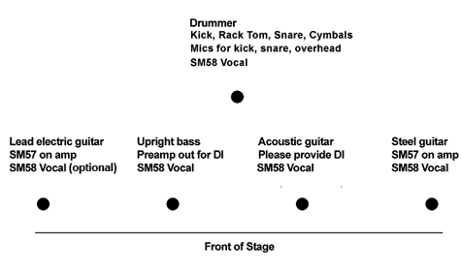
Notes:

- Spread vocals and acoustic guitar evenly in monitors.
- Lead guitar in steel monitor, steel guitar in lead guitar monitor.
- Lead guitar vocal mic is optional.
- Drum kit may also have floor tom.

Contact: Damon Smith
970-545-1765 (cell)
damonsmithmail@gmail.com
www.hibeams.com

